MaRRS International Spelling Bee JUNIOR – National Prelim 2020-21
Dear Qualifier,
! Greetings ! & Wishing you All Good Health & Stay Safe!
DATE: COMPETITION Slots scheduled for: 26th Saturday & 27th Sunday June 2021.
REGISTRATION FEE: Rs.990/- (Inclusive of GST). Register by: 10th June 2021.
ORIENTATION Online: (OPTIONAL): RESERVE A SEAT by 10th June 2021.
Fee: Rs.1590/- (inclusive of GST).
Online Sessions and Soft Copy of Preparatory Material – BOOK.
Date: Online: on Saturday 12th June 2021
Duration: 2 Online Sessions of 40 min.
Time: 03:00 to 05:00 p.m.
Keep Ready: Notebook, Compass box, Water, Snacks.
One day before the session you shall receive the zoom link to join the session.

Please note the PAYMENT PROCEDURE given below:
Rs.990/-: Competition Fee. (inclusive of GST).
Rs.1590/-: Orientation (inclusive of GST). Online Sessions and Soft Copy of Preparatory Material – BOOK.
Payment procedure: Ensure you note the TRANSACTION NUMBER.

Important: Please write MISBJ NP: “Student's name” in the details bar when making the payment

1. You can send the money using this BHIM QR


2. or using my UPI ID 98191 06763@upi. Use BHIM or any other UPI enabled App to make transactions.

3. or Online Transfer:
A/C Name : EDU PLANET A/C No.: 0669 2000 00 1554
IFSC Code : HDFC0000669 Branch : Mahakali Caves Road, Andheri (E)
Account Type : Current Account

Please note fill the Registration Form after payment on
the link: https://forms.gle/jVAqcy4iXjwMtQJq8

INSTRUCTIONS:

- Login with your CIN (User Name & Password is the CIN) for Free DOWNLOADS on http://www.marrsspellingbeejunior.com/site/index
- 18th June 2021: Registered Students shall receive an email for the Online Competition Slot. Booking open from: 18th to 22nd June 2021.
- Please note, for any query send an email to marrs4mumbai@gmail.com. Do mention Name of Student, Category, School.
With Warm Regards
For MaRRS Intellectual Services
Mrunal Datar
EDU PLANET +91 98191 06763 (Please save to receive WhatsApp message if any).
MaRRS International Spelling Bee JUNIOR – National Prelim 2020-21
Online ROUNDS: (Please follow the academic year (2020-21) standard / category).
- The Entire competition will take 30 mins.
MISBJ: JUNIOR KG.

1. FILL IN THE DUPLICATES  Copy the duplicate letters from the word given to fill in the blanks.  Eg: BELL  W_ _ _ Answer: WELL | 2. BLENDING SOUND  Identify the picture. Choose and fill in the blank with appropriate blending sound.  Eg :   ___APE Answer: GRAPE | 3. SIGHT WORDS: SYNONYM  Tell a word that means the same as the word given.  Eg:  Sight word: big.  Synonym: huge. | 4. FUN WITH SENTENCES  Make a sentence connecting the picture and the sight word.  Eg: SEE   Answer: We see with our eyes. | 5. PICTURE QUIZ  Tell two sentences about the picture shown.  (Pictures of things we see around us.)

1. SUDOKU: Fill in the crossword boxes using the picture given as clue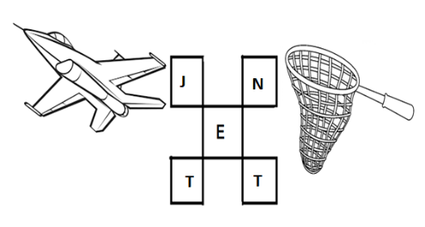 | 2.PICTIONARY: Combine the picture words = to form the final picture word.        Ear+Phone  +  =  = Earphone | 3. LEARNING MY SOUNDS  Read the word with the correct sound of the vowels or consonants highlighted. | 4. FILL UP THE BLANKS  Read the given sight words in red and fill up the blank with the most appropriate word. | 5. NOUN/ VERB/  ADJECTIVE  Read the word and answer the question.  Eg: Tell an action word (Verb) for sight word given.  CHAIR Answer: sit
MISBJ: SENIOR KG.

